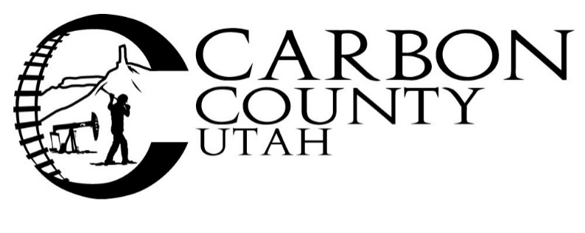
Request for Bids
Cab and Chassis Truck
Carbon County Road Department is accepting sealed bids for a new, 1-ton, cab and chassis pickup truck. Minimum criteria for the pickup are as follows: White, regular cab, 4x4, 84-inch cab to axel, tow-ready, diesel engine, power take-off capability, cloth seats, carpet, and hands-free communication capability.
Sealed bids are due at the Carbon County Clerks’ office at 751 East 100 North Suite #1100 Price, Utah 84501, prior to 3:00 p.m. on October 5th, 2022.
Please note on the outside of a sealed envelope:
2022 Cab and Chassis Bid for Carbon County Road Department
Carbon County is not responsible for bids that are late due to delays in delivery by any source. Faxed and emailed bids are not acceptable.
Bids will be opened during the regularly scheduled Carbon County Commission meeting at 4:30 p.m. on October 5th, 2022 at the aforementioned address in the Commission Chambers.
Carbon County reserves the right to reject any or all bids, to waive any informality of any bid, and to select the bid which in the opinion of the County provides the best product, warranty and/or service to the County.
For further information please call the Road Department at 435-636-3268 between 7:00 A.M. and 5:30 P.M. Monday through Thursday.

