RESIDENTIAL ACCESSORY STRUCTURE
BUILDING PERMIT

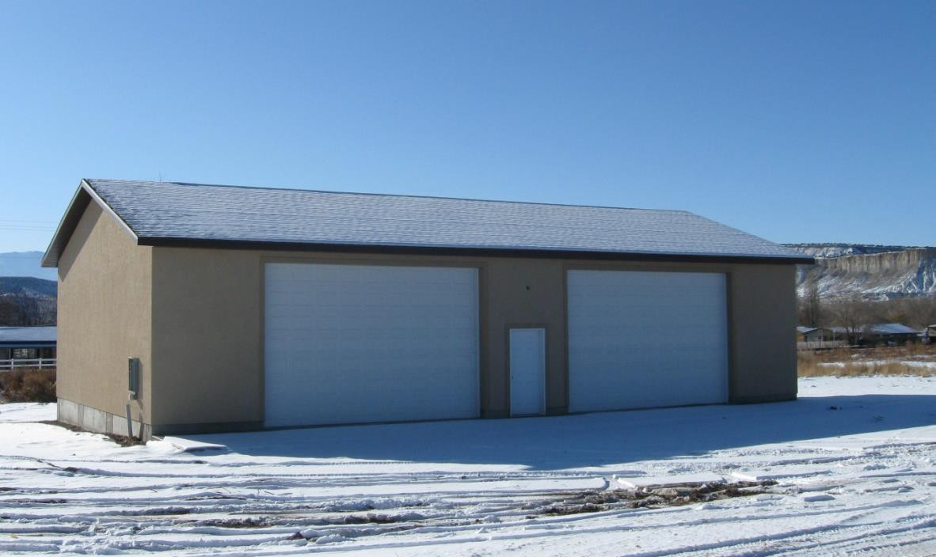

CARBON COUNTY BUILDING DEPARTMENT
751 East 100 North
Suite 2600
Price, UT 84501

Director of Planning
435-636-3261

Building Inspector
435-636-3745

Permit Tech
435-636-3260

Residential Accessory Structure Checklist:
*All building permits are applied for online at www.carbonutah.com
- Completed and signed permit application through the application portal, including the contractor’s name and license number
- A signed Owner/Builder Certification Form, if owner will be completing the work
- A site plan drawn to scale showing lot shape and dimensions, showing the street, front of the lot, and the setbacks to property lines of all existing and proposed structures
If the property is within the city limits of East Carbon, Helper, Price, Scofield Town, or Wellington, additional time may be necessary for city zoning approval and a zoning fee may be required. Please contact the appropriate city for additional information.
- PDF/digital plans drawn to scale (not less than 1/4” = 1’) showing:
  - Manufacturer’s engineered plans required
- Footing and foundation plan
- Wall framing, columns and beams with sizes – a cross section is preferred
- Floor framing, girder, joist and blocking sizes and spans
- Roof framing, rafter size and span or stamped truss sheet details (truss sheets may be deferred if on plan)
- Electrical plan (if applicable)
- Plumbing plan (if applicable)
- Heating cooling and ventilation plans (if applicable)
- Gas pipe sizing calculations (if applicable)

- Engineered WET stamped plans may be required for structures in the Scofield area D₀ Seismic zone, basement walls over 9’, unusual construction and the foundation design of all steel structures. Copies will not be accepted.
NO APPLICATIONS WILL BE ACCEPTED WITHOUT ALL OF THE ITEMS THAT ARE LISTED ABOVE.
15 BUSINESS DAYS ARE NORMALLY REQUIRED TO PROCESS YOUR APPLICATION FOR APPROVAL.
Work exempt from a building permit includes:
- Agricultural buildings that meet the requirements for the Utah agricultural building exemption
- Sheds and structures under 200 square feet
- *Agricultural buildings and sheds less than 200 square feet will require zoning approval for setbacks
- Fences not over 7 feet high
- Retaining walls that are not over 4 feet high from bottom of footing to top of wall Sidewalks and driveways
- Painting, papering, tiling, carpeting, cabinets, counter tops, and similar finish work Prefabricated swimming pools less than 24 inches deep
- Swings and playground equipment
- Window awnings supported by an exterior wall
- Decks under 200 sq. feet, less than 30” above grade, not attached to dwelling & not main door.

Additional forms & guides available at https://www.carbonutah.com

RESIDENTIAL
SITE PLAN REQUIREMENTS

SITE PLANS: (See below for sample site plan)

- Drawn to scale with North arrow indicated.
- Show parcel shape and dimensions.
- Show location of all buildings, existing and proposed with distances between buildings and to property lines.
- Entrance/access direction and location of building for addressing purposes.
- Locations of: (buried and overhead)
  - Powerline(s) –buried and overhead
  - Waterline(s)
  - Location of sewer or septic system (drain field)
  - Utility easements
  - Dedicated easements or rights of way
  - Ditches and/or canals
- Locations and names of roads
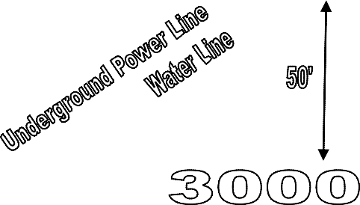
- Site Plans/subdivision plats submitted electronically when possible N

